Changes in Master:-
- Master CR - GM / Contractor – Option for Manual Entry for Components
- Master CR – Schema -
  - In Bulk Consumer Master – Add Delete Functionality
  - Bulk Consumer Master – (Add-Update-Get)
  - Vistrit Summary Report - Mapped Status report changes in summary report & abstract report
  - Vistrit
    - Scheme Bulk consumer master :
      - Divide screen into 2 sheets
        - Add Bulk Consumer – Add further fields such as Agreement copy & Total Supply points of bulk consumer. Action Button Edit & Delete
        - Map Bulk Consumer
    - Scheme Village Master:
      - Addition of Validation and logic on “Is a Bulk village”, “Is water supply testing started by firm”, “Is water supply permitted by GM PIU”. Action button check for Edit
      - Check OHT Village Master Mapped column and Census Population
    - OHT Village Master - OHT Master Mapping Report Updations such as local name column addition
    - WTP Meter Mapping – Table column fields increased - like Meter Name, No of Connected OHT, Meter Type, Action Button.
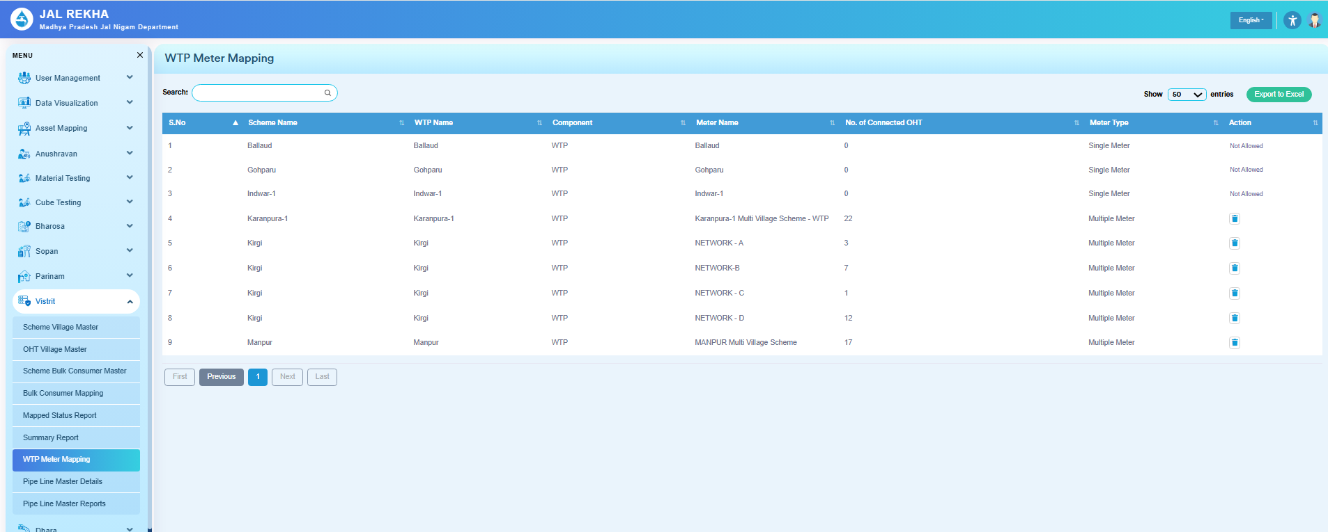

- Addition of Pipeline Master Details & Report Pages.
[4:00 PM, 6/10/2026] Awinash Khare MPSeDC: Following villages in Mohkhed scheme having issues in Dhara entries :
- 1.Palakhed -2 Tapping point
- 2.Saroth -3 Tapping point
- 3.Ikalbehari -3 Tapping point.
- 4.Jam -2 Tapping point.
- 5. Mohkhed -2 Tapping point

- In the above following villages ,when the FE is trying to enter the details of meter for 1 tapping point ,the same reading is replicated automatically in other tapping points of same village ,whereas different tapping points has meters installed and working properly,then also the meter entries for 1 particular tap point is being fetched and replicated in every tap point .
- Please resolve this issue ,such that we (FE) can be able to enter meter details for every tap point seperately for a particular village.
- @~Kailash @Tapan Sir Jal Rekha MPSeDC
- [4:00 PM, 6/10/2026] Awinash Khare MPSeDC: Remove the restriction in entry of contract details
- [4:00 PM, 6/10/2026] Awinash Khare MPSeDC: Please allow entry for all schemes
- [4:00 PM, 6/10/2026] Awinash Khare MPSeDC: 1) Updation of report format for meter reading survey (all) as discussed on friday
- 2) Updation of summary report
- 3) Hyperlinks in all DWSR's
- 4) Abstract of contract details
- [4:00 PM, 6/10/2026] Awinash Khare MPSeDC: Not show Nemawar and Rignod Mvs
- [4:01 PM, 6/10/2026] Awinash Khare MPSeDC: Please check it Anklan me entry k liye Nemawar and Rignod reflect nhi ho rhi h
- [4:01 PM, 6/10/2026] Awinash Khare MPSeDC: Dhara meter approved data..me jo dates likhi hai..wo kya bta rha h..kya koi beech me kisi data ko approve kr skta hai..mtlb 1-5 april ka data approve nhi kiya aur 6 ka data approve kr diya..to is report me ye show krega 6 april tk ka data approve ho gya h..jbki keval 6 april ka data approve hua..pls check

